We invite researchers, professionals, and students to submit abstracts for the upcoming TIM 2025 conference. The theme of the conference is Advancing Digital, Smart, and Resilient Transportation Infrastructure. Any topics related to this theme are welcome.

Important Dates

- Abstract Submission Deadline: April 25, 2025

- Notification of Acceptance: May 9, 2025

- Full Paper Submission Deadline (for ASCE Special Publications): June 13, 2025
(manuscript preparation guide will be provided)

Submission Guidelines

- Use the attached abstract template to prepare your abstract.

- Please indicate your submission category (one of the following categories) in your abstract.

- You must select your submission categories (select all applicable) when submitting your abstract:

☐ Presentation Only
☐ Student 3-Minute Presentation Competition
☐ Student Poster Competition
☐ Full Paper ASCE Conference Proceedings Submission

- Please submit your completed abstract as a Microsoft Word document (.doc or .docx), named Lastname_Firstname_Abstract.docx, to ictim2025@gmail.com.

- For any questions or assistance, please contact ictim2025@gmail.com.

DEVELOPING STONE MATRIX ASPHALT AND HIGH-QUALITY HOT MIX ASPHALT MIXTURES WITH LOCALLY AVAILABLE COARSE AGGREGATES

Jenny Liu, Missouri University of Science and Technology (S&T)

ABSTRACT:
Multiple well-distributed aggregates have been evaluated in this study as candidate coarse aggregates, including traprock (control), chat, gravels, steel slag, limestone, and dolomite. A series of screening tests of aggregates were conducted including 1) general physical properties required in state specification, and 2) Micro-Deval abrasion test, post-compaction degradation assessment, and soundness tests to assess their resistance to polishing, degradation, and freeze-thaw damage, respectively. SMA and HMA mixtures with qualified candidate aggregates were then designed in accordance with the AASHTO R46 and R35, respectively. Following the volumetric design, performance tests, including the Humburg Wheel Tracker rutting tests and IDEAL-CT cracking tests, were conducted for performance verification.
The study found that gravel can be utilized to be the alternative aggregate in both SMA and HMA, passing the aggregate durability and mixture performance criteria. Using limestone or dolomite alone as the coarse aggregate in both SMA and HMA mixtures would yield challenges to meet the requirement in VMA. However, the mixtures with blends of chat & dolomite and chat & limestone achieved acceptable volumetric properties and promising cracking and rutting resistance. With the performance optimum binder contents, the SMA and HMA mixtures with steel slag successfully met all requirements for volumetric properties, moisture susceptibility, draindown percentage, workability, and resistance to cracking and rutting.

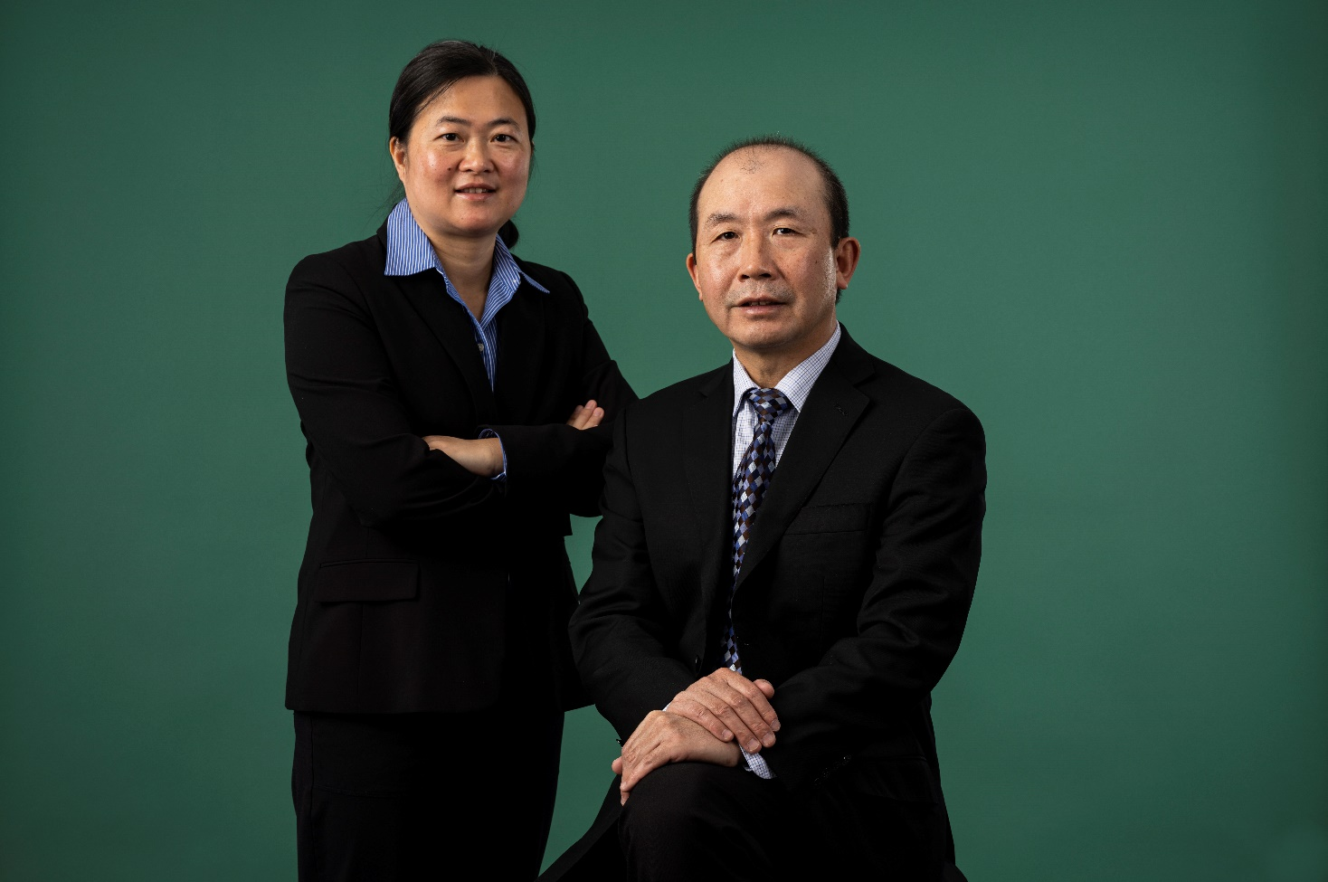
BIO:
Dr. Jenny Liu is James A. Heidman Professor in Civil Engineering at Missouri S&T. She received her PhD degree from Texas A&M University. Prior to joining S&T, she was a professor at University of Alaska Fairbanks and Founding Director of Center for Environmentally Sustainable Transportation in Cold Climates. Her research focuses on engineering characterization and modeling of infrastructure materials, pavement design, performance evaluation and testing, pavement preservation, non-destructive testing, and pavement management system. She has secured over $15 million funding for about 50 research projects in these areas sponsored by US DOT, State DOTs, DOE, local government, and industry. She is currently the Committee Communications Coordinator of TRB Pavement Preservation Committee, and an Associate Editor of three ASCE Journals (Journal of Materials in Civil Engineering, Journal of Transportation Engineering Part B: Pavements, and Journal of Cold Regions Engineering), and a member of several ASCE and TRB committees. She served as the President of IACIP and Chair of ASCE Bituminous Materials Committee. Her work has been recognized by several awards including 2019 S&T Faculty Research Award, four times of Best Paper award from international conferences, two times of ASCE Outstanding Reviewer, and 2016 Engineer of the Year of Alaska Society of Professional Engineers Fairbanks Chapter. She is a licensed PE in Alaska.

Submission Categories (select all applicable)
☐ Presentation Only
☐ Student 3-Minute Presentation Competition
☐ Student Poster Competition
☐ Full Paper ASCE Conference Proceedings Submission

